MISSION:

Printing Instructions

Print off Slide 2 on its own – set as 2 pages per sheet Print off 3-13 as a Booklet on Printer Settings Print off 14 & 15 as full pages
Print off 16 as 2 pages per sheet

The titles on slide 16 are to be used for sticking on the envelopes holding the Mission’s Required Contents such as ‘jigsaw pieces’ and ‘bunting’ and ‘string’
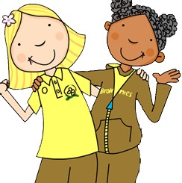

MISSION:

TALES FROM TWINKLE OWL: PROMISE MISSION FOR NEW BROWNIES
Mission: Promise
Mission Number One:
To Secretly Serve Others

Mission Number Two: To Be True To Myself

Mission Number Three:
Fingers & Thumbs:The Brownie Salute

Mission Number Four:
Problem Solving

Mission Number Five: Brownie Bunting

Mission Number Six: Muddled Queen

Secret Agent:

.…………………………

Your mission, if you choose to accept it, is to complete a series of Challenges in order to help you understand ‘What it is to be a BROWNIE’ & the BROWNIE PROMISE!

The Brownie Promise

I Promise that I will do My Best: To be True to Myself
And Develop My Beliefs To Serve the Queen & My Community
To Help Other People
And to Keep the Brownie Guide Law

Brownie Guide Law

A Brownie Guide Thinks of Others Before Herself & Does a Good Turn Everyday.

For the Next Seven Days you are required to
perform random good deeds in order to help other
people.

First, you must pick your target. This will be the person you will help.
Then, you must decide on a kind deed or act to perform for them.

DO NOT BLOW YOUR COVER!

Examples of kind deeds or acts:
• Do a chore.
• Write a note to someone telling them how much
you appreciate them.
• Smile at 3 random people.
• Bake something for someone.
• Pick up rubbish on your way to school.
• Set the table for dinner.
• Do your homework without being asked.
• Read to a little Brother/Sister.

Good Luck Agent on Your Mission to
Secretly Serve Others!

 | Your Target | Your Good Deed
Wednesday
Thursday
Friday
Saturday
Sunday
Monday
Tuesday

Mission Number Two:
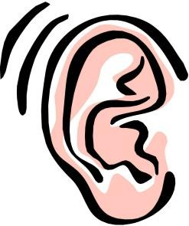To Be True to Myself

What makes you Happy?

Record your favourite things to smell, see, hear, taste and do to show who YOU are.
Smelling…

----------------------------- Makes Me Happy!
Hearing…

----------------------------- Makes Me Happy!
Seeing…

----------------------------- Makes Me Happy!
Tasting…

----------------------------- Makes Me Happy!
Doing…

----------------------------- Makes Me Happy!

Mission Number Three:
Fingers & Thumbs
The Brownie Salute

Agent, it seems this hand cannot remember how to salute! Fold down the right finger and thumb on the paper hand in
your Mission Pack in order to
show the Brownie Salute.

This is the action which you must do while saying your Promise.

Mission Number Four:
Problem Solving

B | C | A | L | A | W | B | Z | F | A | E | G | R | N | G
R | O | P | M | I | L | R | W | P | D | S | E | T | U | U
O | W | H | R | I | H | E | L | P | F | U | L | H | O | I
W | D | I | Q | O | D | N | M | I | E | N | A | C | M | D
N | T | P | I | A | M | A | B | O | R | W | X | O | N | E
I | B | B | W | O | P | I | E | S | S | O | O | M | T | S
E | U | E | P | R | O | L | S | E | K | L | I | M | R | F
S | H | B | O | B | T | Y | T | E | P | S | Q | U | H | G
S | F | R | I | E | N | D | B | Q | S | G | F | N | G | N
U | N | O | L | L | A | S | E | I | B | K | E | I | S | I
Q | K | W | H | I | F | M | O | U | R | E | G | T | E | V
O | I | N | B | E | W | N | P | H | U | R | B | Y | T | L
K | N | O | E | F | I | W | T | Q | P | E | R | R | O | O
P | D | W | R | S | N | O | W | Y | O | W | L | G | P | S
N | J | L | A | O | P | D | S | P | E | O | P | L | E | A

Mission Number Four:
Problem Solving

• Brownies
• Promise
• Law
• Helpful
• Guide
• Community
• Mission
• Best
• Brown Owl
• Friend
• Beliefs
• Kind
• Snowy Owl
• People
• Solving
• Queen

Try to solve the problem of the hidden words in the Words Search.
Hunt out each of the words on this list in the Word Search.
Mission Number Five:
Brownie Bunting

In your Mission Pack there is a set of
Triangles.

Each Triangle has a part of the Brownie Promise on it and two punched holes at the top of it.

Agent, sort the BUNTING TRIANGLES into order so that it spells out the Promise.

Then thread the Promise onto the
STRING (in your Mission Pack) in the
right order.
Mission Number Six:
Muddled Queen

Secret Agent, we need you! The Queen is all in a MUDDLE!
In your Mission Pack there is a set of paper jigsaw pieces.
This jigsaw is a portrait of the Queen. Stick the pieces
onto this page in the right order to create the perfect
picture of the Queen.

Mission Number Three:
Fingers & Thumbs
The Brownie Salute
I promise that
I will do my best

& develop
my
beliefs
To serve the Queen

To help other people
& to keep
the Brownie
Guide
law

Mission Number Six: Muddled Queen

Mission Number Five:
Brownie Bunting

To be cut up into pieces

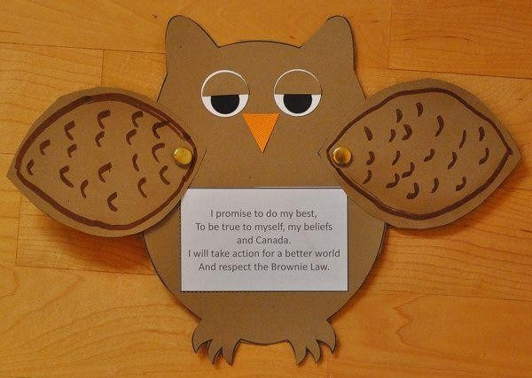

To be made for
Promise
Ceremonies

